EDUCATION WORLD
3V AND 5V SECTION IN NEW GENERATION LAPTOP MOTHERBOARD FOR CHIP LEVEL REPAIR TRAINING COURSE
https://www.youtube.com/watch?v=LzXwuAIokH8&list=PLOpj18mZ_tHMfyXK6BAdSncIIPP7uhw-2
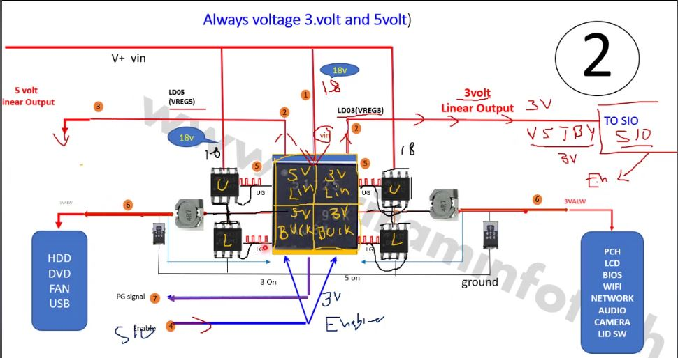

3 3VOLT AND 5 VOLT SECTION IN LAPTOP IN LAPTOP
https://www.youtube.com/watch?v=lhd5b_DupGg&list=PLOpj18mZ_tHMfyXK6BAdSncIIPP7uhw-2&index=2
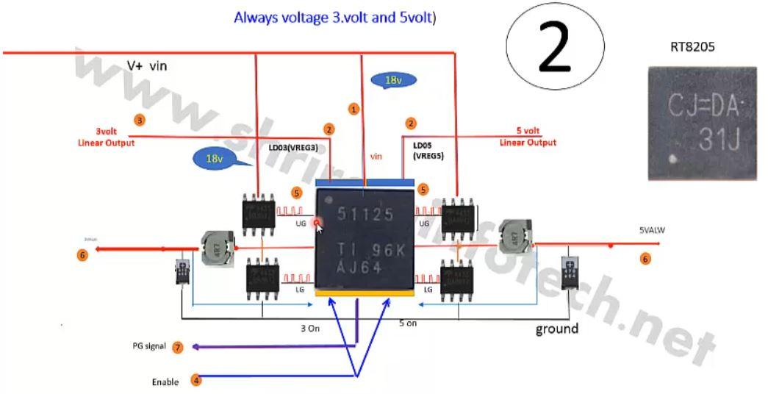

VIN → Charging → 3V/5V → Power Sequence → BIOS → CPU → RAM → Display
3VALW → LDO3 → SIO → Power Button → EC Trigger → ON Sequence

